Net3006A Network Management and Measurements

Assignment 2 (Lectures 5 – 8) **- Due February 28, 2025**

Please submit **a single PDF file** to “Assignment 2” on Brightspace

**Q1.** [1.2 Point] Answer the following questions in one or two sentences.

1. Why do we say that information in a MIB is more heterogeneous than information in typical databases?

It can store a wider variety of data types that typical databases can and can organize it in a hierarchical manner using fewer instances.

1. Managers usually do not cache state information. Briefly explain why.

Managers do not cache information because they only need to know current information about the network which frequently changes.

1. Briefly explain why a table or a table entry object is not accessible in MIB-2.

The table or object are conceptual so accessing them isn’t necessary.

1. What is the relation between “requests and responses” and “polling”?

Requests and responses are the most common form of communication between managers and agents to perform actions.

Polling is simply another application of requests and responses to gather information from agents within the network over time.

**Q2.** [1.2 Points] Answer True or False for each of the statements below and briefly explain why in one or two sentences.

1. A MIB module corresponds to a subtree in the OID tree.

True because a MIB modules defines a set of managed objects under a unique OID prefix.

1. When using polling for information retrieval, a low polling frequency should always be adopted, since lower frequency means less communication and processing load.

False because a lower polling frequency has a higher likelihood to missing critical events, however this depends on the current network topology and set up.

1. Consider the case of missing response after a configuration request. If the manager is sure that the response was sent by the agent but got lost in transmission, then the manager can also know for sure that it does not need to resend the configuration request.

False, a manager because if a manager is aware that their request got lost in transit, however since it didn’t get a response by the agent it will check to see if configurations were made before resending the configuration request.

1. In order to implement proactive network management, it is necessary to use events- based information retrieval instead of polling-based information retrieval.

True, because events-based information has the existence of Threshold-Crossing alerts which enables a proactive network management approach since it creates a warning system.

**Q3.** [1.6 Point] Suppose that a manager is monitoring an agent for an unusual condition (e.g., unusual traffic load). The agent wants to compare polling-based approach (the left half of Fig.1) and event-based approach (the right half of Fig.1). You are given the following information:

* + The entire duration of monitoring is 𝑇 (beginning with 𝑡 = 0 and ending with 𝑡 = 𝑇)
  + The unusual condition will happen within the monitoring duration exactly **once**
  + The duration of the unusual condition is 𝑇𝑐
  + The usual condition is **equally likely** to begin at any instant between 𝑡 = 0 and 𝑡 =

𝑇 − 𝑇𝑐

For polling-based approach, the following simplification is made:

* + Queueing/transmission/processing/propagation delay, packet loss, or packet error are all neglected.
  + The gap in time between a response and the corresponding request is 0
  + The size of each request is 𝐷𝑞, while the size of each response is 𝐷𝑠
  + The first request is sent at 𝑡 = 0
  + The frequency of polling is 𝑓𝑟 , which means the gap between any two adjacent requests is 1/𝑓𝑟
  + The unusual condition is detected if a request is sent during the condition and missed otherwise.

For event-based approach, the following simplification is made:

* + Queueing/transmission/processing/propagation delay, packet loss, or packet error are all neglected
  + The gap in time between the beginning of the unusual condition and the event message is 0

Given the above information, answer the following questions

1. [0.3 Points] Suppose that the polling-based approach is used. Assume 𝑇 is very large (𝑇 → ∞), 𝑇𝑐 = 10 seconds, and 𝑓𝑟 = 0.05 Hz. What is the chance (probability) of the manager missing the unusual condition. Explain your answer.

$Request frequency=\frac{1}{fr} so\frac{1}{0.05}=20 seconds$

$Given Tc=10 seconds$

$Pmissed=1-\left(Request frequeny*Tc\right)→1-\left(0.05*10\right)=0.5=50\%$

1. [0.3 Points] Suppose that 𝑇 = 100 seconds, 𝐷𝑞 = 103 bits, 𝐷𝑠 = 104 bits, and the rest is the same as in Q3.a. Once the unusual condition is detected, the manager stops polling. What is the minimum (i.e., the best-case) total amount of data exchange in the duration from 𝑡 = 0 till detecting the condition? What is the maximum (i.e., the worst-case) total amount of data exchange in the duration from 𝑡 = 0 till detecting the condition? Explain your answer.

Given the following:

T = 100 seconds

Dq = 103 bits

Ds = 104 bits

Fr = 0.05 hz

The best case would be:

Data = Dq + Ds = 103 + 104 = 1.1 x 104 bits

The worst case would be:

Data = 5(Dq + Ds) = 5(103 + 104) = 5.5 x 104 bits

1. [0.6 Points] Now assume 𝑇 is again very large (𝑇 → ∞). You are not given the specific values of 𝑇𝑐, 𝑓𝑟, 𝐷𝑞, or 𝐷𝑠 but should treat them as variables. Can you express
   * The chance (probability) of missing the unusual condition
   * The amount of data exchange per second before the unusual condition begins
   * The average delay in detecting the condition (from the instant when the unusual condition begins till the instant when the manager detects the instant) – here we can assume the condition is detected.

using variables 𝑇𝑐, 𝑓𝑟, 𝐷𝑞, or 𝐷𝑠 for the polling-based approach and for the event- based approach, respectively?

Polling based:

Based on the probability of missing using the following:

$Pmissed=1-\left(Request frequeny*Tc\right)$

$Polling rate = fr\left(Dq + Ds\right)→Average delay would be=1/2f_{r}$

Events Based:

Using the following:

Data = fr(Dq + Ds)

Considering that polling will occur every 1/fr the delay would be between 0 and 1/fr

Therefore Dpolling = 1 / 2fr

1. [0.2 Points] Compare your answers for the polling-based and the event-based

approaches to Q3.c (if you solved Q3.c), which one is better? You can discuss in general if you did not solve Q3.c.

|  |  |  |  |
| --- | --- | --- | --- |
| Metric | Polling-Based | Event-Based | Who is better? |
| Probability of missing condition | 1 - frTc | 0 | Event-based |
| Data exchange rate before condition | Fr(Dq + Ds) | 0 | Event-based |
| Average detection delay | 1/2fr | 0 | Event-based |

Based on my table above it is clear to see that event-based is better in all three aspects since the condition is never missed, avoids unnecessary data usage and said condition would be detected immediately.

1. [0.2 Points] Can you explain (based on your answers to Q3.c if you solved Q3.c) what kind of trade-off exists if the polling-based approach is used. You can discuss in general if you did not solve Q3.c.

If there is a lower polling frequency, its more likely that any unusual condition would be missed. However, if we were to increase the polling frequency it would make an unusual condition less likely to be missed, however it will require higher data processing and provide more overhead.

(Note: if you are interested, you could verify your answer by conducting a small simulation in MATLAB – or find some inspiration from the simulation to solve the problem.)

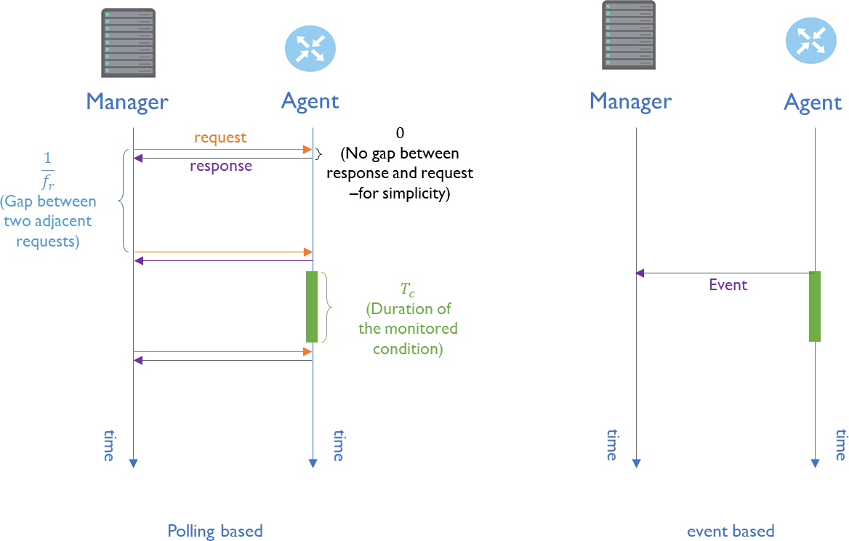

Figure 1: An Illustration for Q3